User Manual: Enabling AWDL (AirPlay P2P) Mode

Device: EZCast Pro Dongle II (D15) and EZCast Pro Box II (B11)
This guide provides step-by-step instructions for activating Apple Wireless Direct Link (AWDL) to enable peer-to-peer AirPlay or Miracast connections. Please note that only one source device is supported at a time and Google Cast (Chromecast) is not supported in this mode.

Step 1: Connect to the Device Wi-Fi
- Power on your EZCast Pro Dongle II and wait for the Home Page to appear on your display.
- Locate the SSID (Network Name) and Password displayed at the top of the Home Page.
- On your computer or mobile device, open Wi-Fi settings and connect to the SSID.
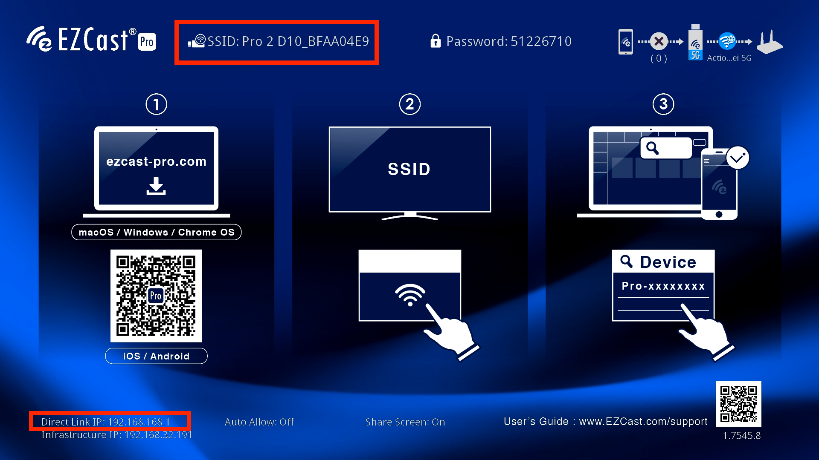

Step 2: Access the Web Setting Interface
- Once connected, look at the bottom-left corner of the TV/Monitor screen to find the IP Address.
- Open a web browser (such as Chrome or Safari) on your connected device.
- Type the IP address into the browser's address bar and press Enter to log into the Web Setting dashboard.

Step 3: Enable AirPlay P2P (AWDL)
- Scroll down the Web Setting page until you find the AirPlay P2P section.
- Toggle the switch to Enable or On.
- The device will now support AWDL, allowing devices to discover and cast via AirPlay/Miracast without needing a shared infrastructure Wi-Fi network.
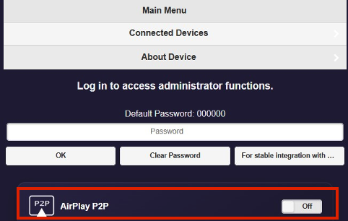

- Once enabled, the device will reboot, and the landing page will appear as below. You can then begin using Miracast/AirPlay P2P mirroring.
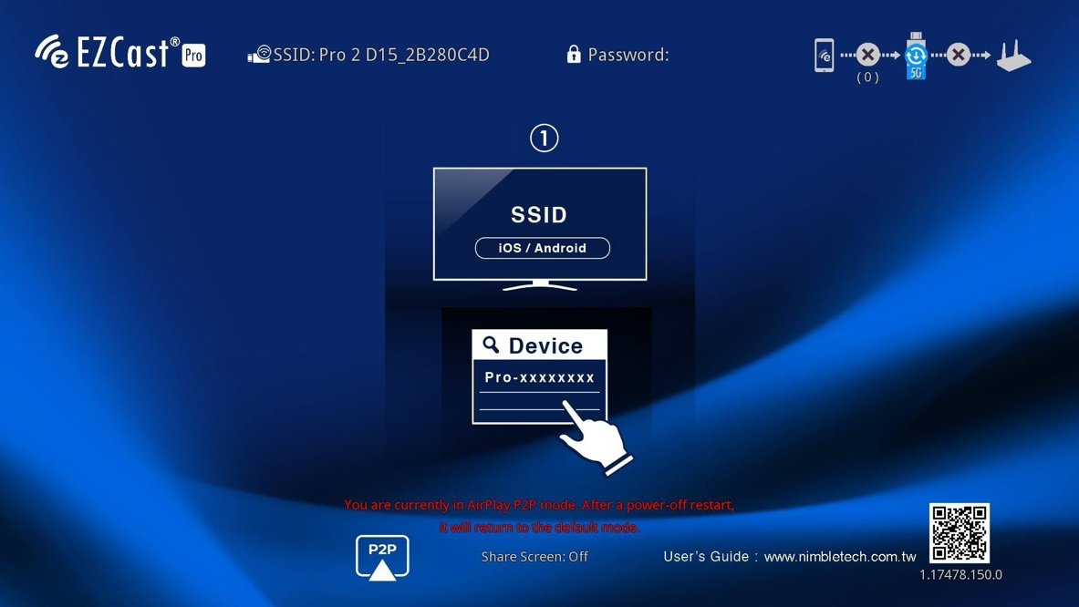
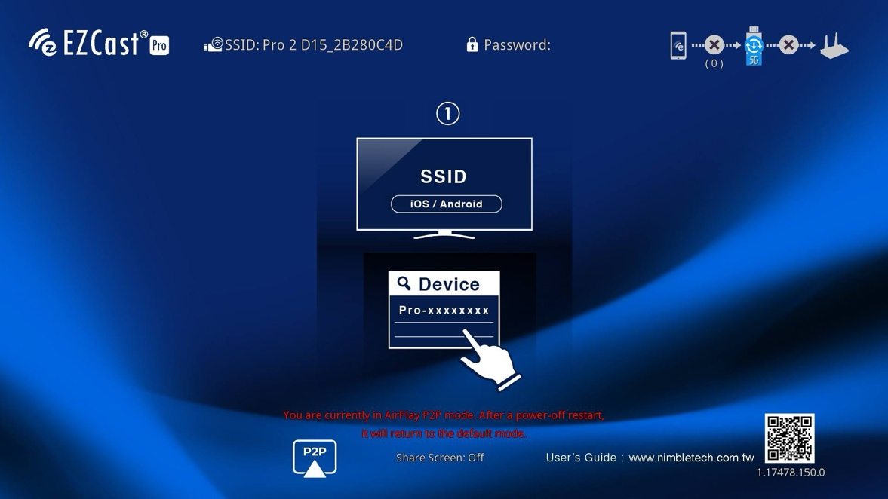

Reverting to Original AP Mode
- To return to the original mode (AP Mode): Simply disconnect the power from the EZCast Pro Dongle II (D15) or EZCast Pro Box II (B11) and plug it back in.
- The device will perform a cold boot and automatically revert to its default Access Point (AP) Mode.

